Application Documentation
User Registration Application

Developed By: Mahesh Ravirala

Aim: This Project is Aimed to delvelop the a simple application to meat the reqirements of Registering A new User and Performs operations Like

i)Creating a New User
ii)Retriving a The User Information
iii)Deleting the User

Displaying the User Information on the User Interface And it is based on Single Page Application

i)Creating A User:

To Create or Register a New User He/She need To Fill the Following information on the form given in the UI. The Fields Are Following

1.Created By
2.Email Address
3.Phone Number
4.Password
5.Role (either user or Agent)

Afer Filling the fields Then submit then it will insert data in the database if it is valid data
else it shows invalid data.

Following ScreenShot Displays the Form To Create the User,

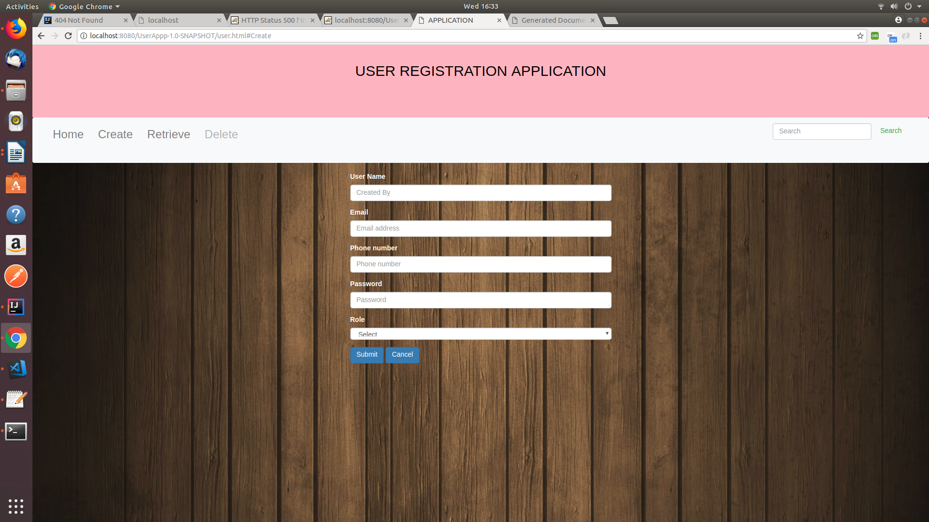
Fig 1: Creating User Form

ii)Retriving a The User Information:
To Retrive the data We can get it by two ways ,

1.Based on UserID
2.Based on Role
Following ScreenShot Displays the Form To Get the User Details,
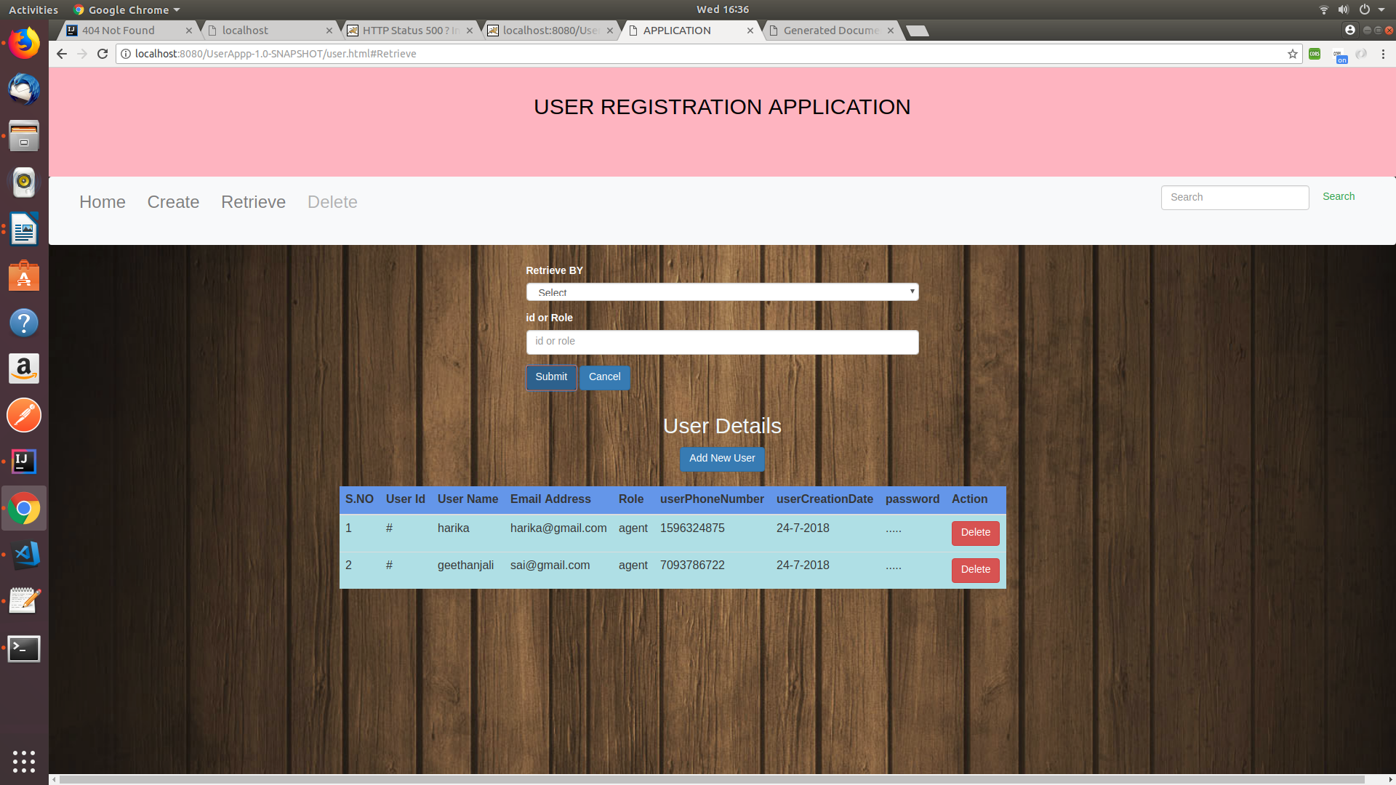
Fig2: Retreving data By UserRole

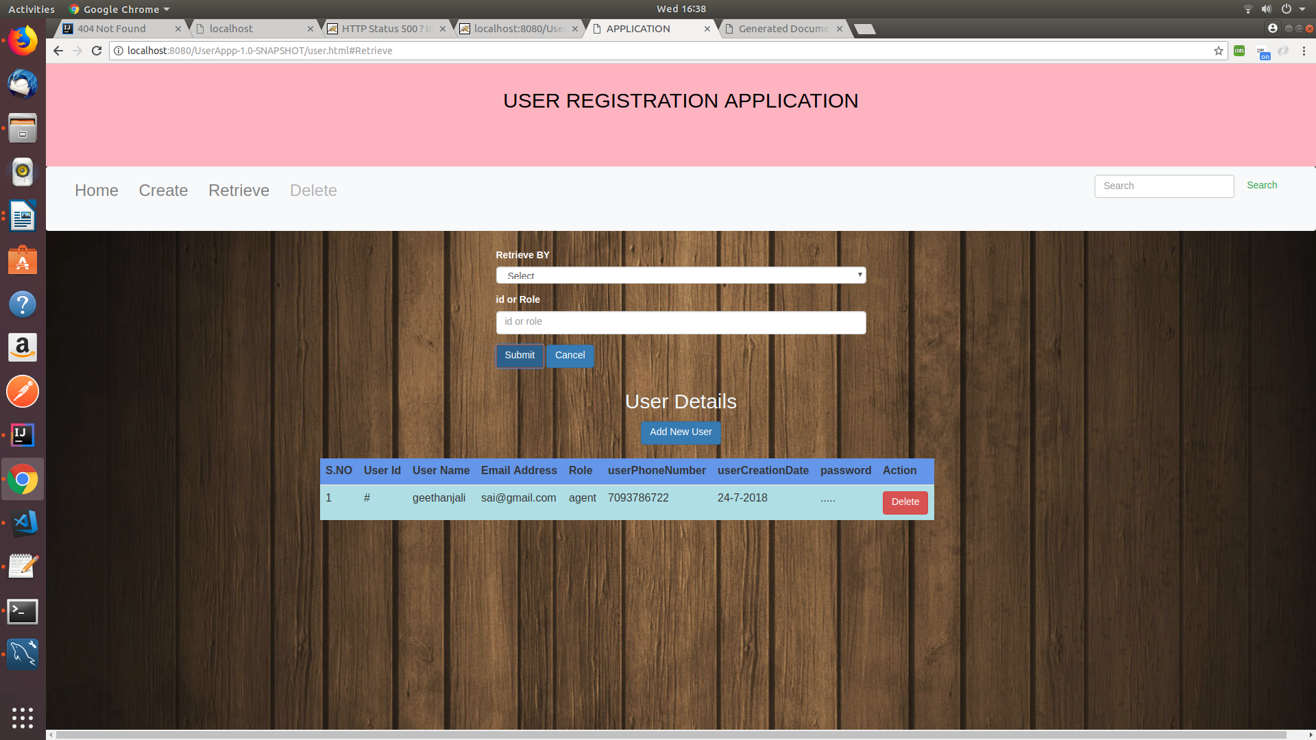

Fig2: Retreving data By UserID
iii)Deleting the User:

Deletion can be done by two ways ,
1.By clicking Delete button on navigation bar and entering admin password and used id
2.By Clicking the button on each row after retreving the user information
if correct information is provided then it will allert as Successfully Deleted else shows error.

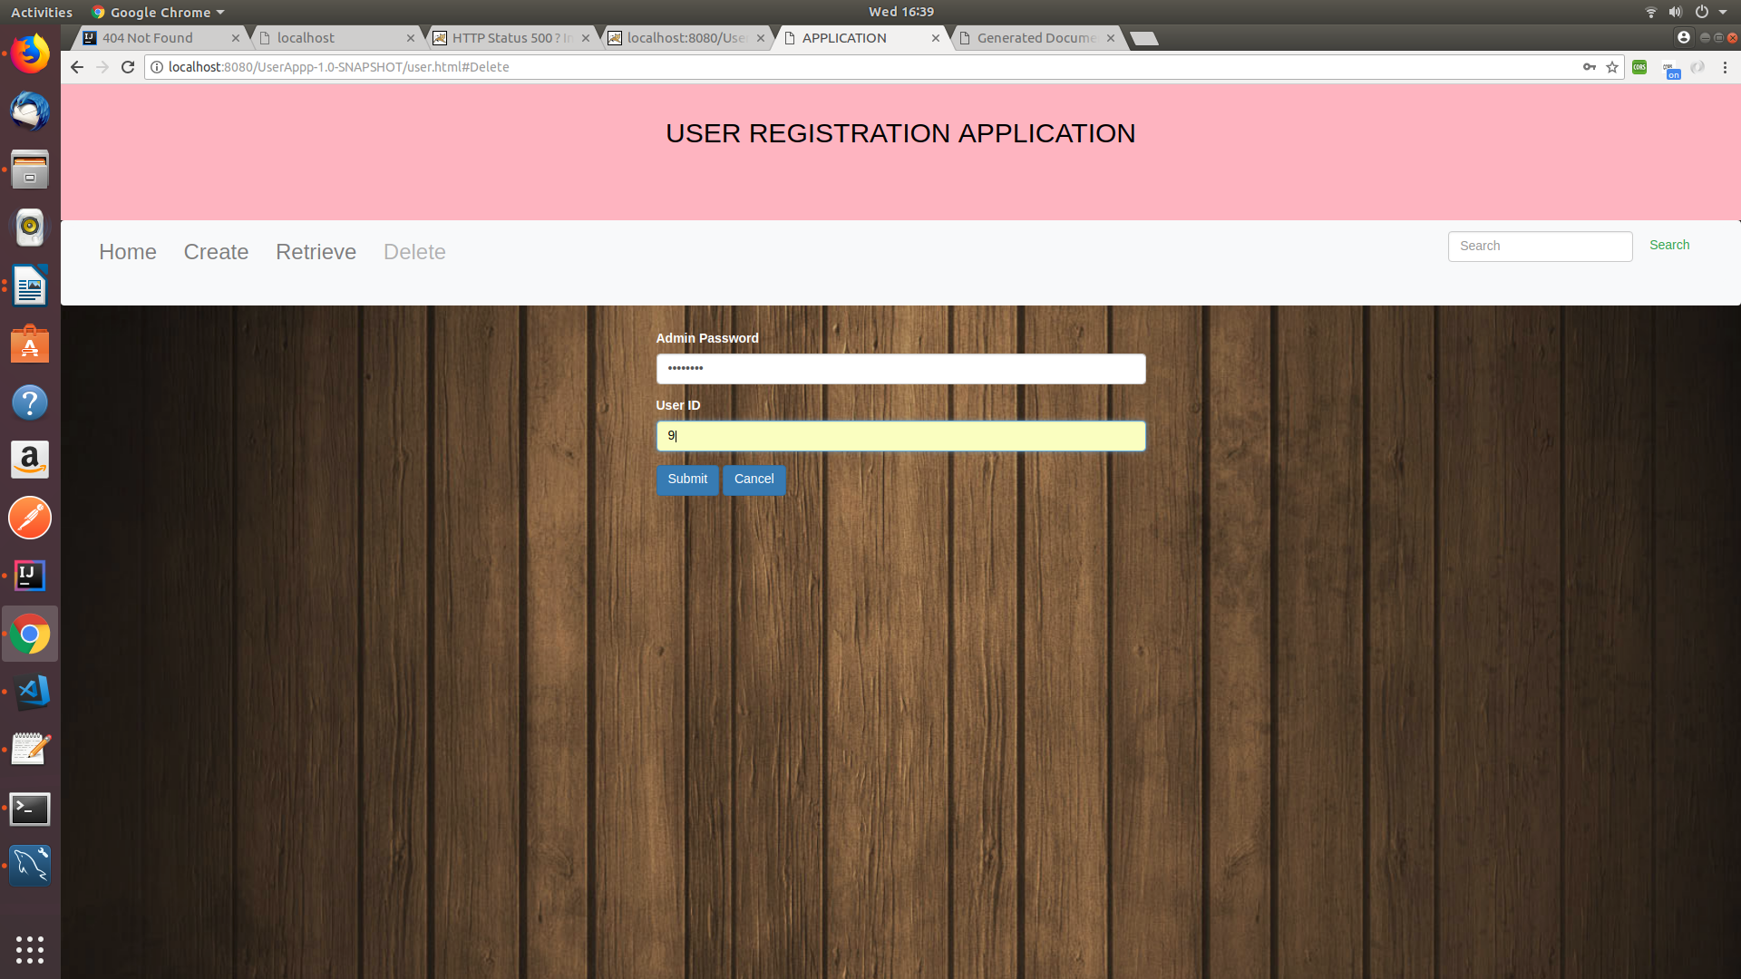

Fig 4.Delete Based On UserId
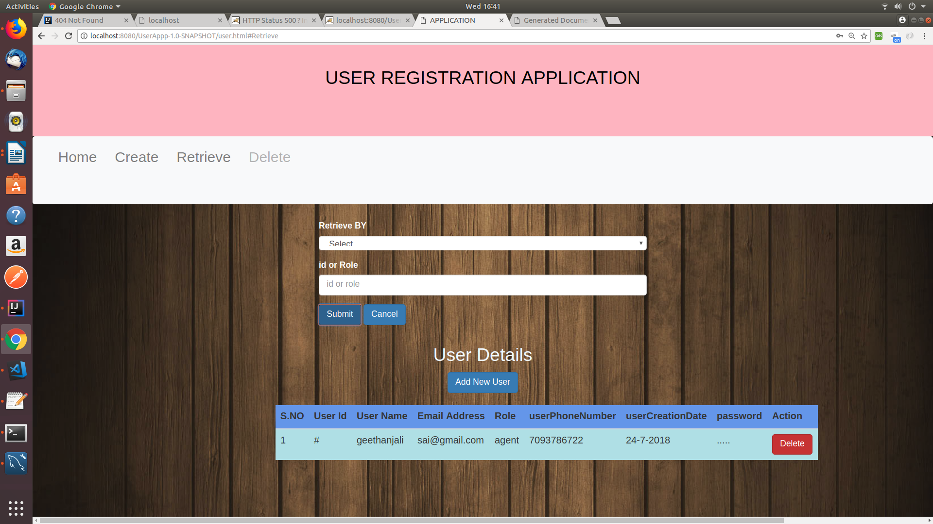

Fig 5:Deleting by clicking the Button on retrival table
Table Schema:

Table Name- UserTable:

-- Table structure for table `UserTable`

DROP TABLE IF EXISTS `UserTable`;

CREATE TABLE `UserTable` (
`userId` int(11) NOT NULL AUTO_INCREMENT,
`userName` varchar(45) NOT NULL,
`userEmailAddress` varchar(45) NOT NULL,
`userRole` varchar(45) NOT NULL,
`userPhoneNumber` varchar(45) NOT NULL,
`userCreationDate` date DEFAULT NULL,
`password` varchar(45) DEFAULT NULL,
PRIMARY KEY (`userId`),
UNIQUE KEY `userEmailAddress_UNIQUE` (`userEmailAddress`),
UNIQUE KEY `userId_UNIQUE` (`userId`),
UNIQUE KEY `userPhoneNumber_UNIQUE` (`userPhoneNumber`)
)

3.Development Requirements :

3.1 Development Languages:

1. Java SE and Java EE(JDK 1.8 Open),

2.JavaScript(ES5 and ES6

3.HTML(HyperText Markup Language)

4.CSS(Cascade Style Sheet)

5.BootStrap

6.Ajax

7.Jquery

3.2: DataBase

i) MySQL :

3.3: IDE’s

i) Intellij
ii)Visual Studio
iii)MySQL Workbench

4.Conclusion:
The Appication is delevoped to meet the minimum requrements by using the Softwate tools and Languages.

5.Future Enhancement:
1.Updating the user Details
2.Login form to access the Application
3.Update the UI With the more user friendly

6.References:
1.www.google.com
2.Bootstrap.org.

